NOR-SOLIDARITY DMC report

Inge Christoffer Olsen, PhD

17 October, 2020

# Introduction

This is the report for the first Data Monitoring Committee meeting in the NOR-SOLIDARITY trial. The data are based on an export from the Viedoc electronic data capture system time stamped 28 April 2020 13:49 UTC. There were 185 included patients.

# Inclusion status

## Inclusion rate

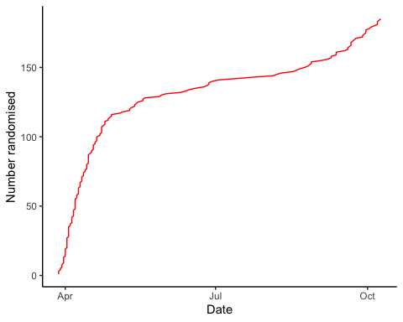

## Inclusion by hospital

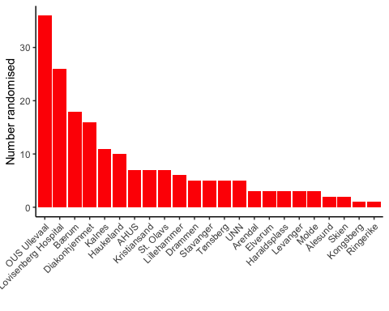

## By treatment

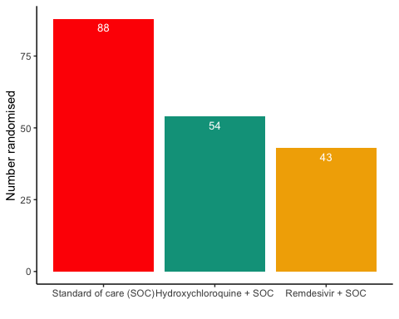

# Demographics

Demographics

Parameter

SOC (N=88)

SOC + HCQ (N=54)

SOC + Remdesivir (N=43)

Age (years)

59.3 (16.1)

60.3 (13.8)

60 (16.4)

Female, n (%)

28 (31.8%)

21 (38.9%)

13 (30.2%)

# Exposure

Exposure to study treatment

Parameter

Hydroxychloroquine + SOC

Remdesivir + SOC

Total dose, median (IQR), mg

5200 (3600 - 8400)

700 (500 - 1100)

Days with treatment, median (IQR)

6 (4 - 10)

6 (4 - 10)

Patients with any treatment discrepencies, n (%)

23 (42.6%)

11 (25.6%)

# Adverse Events

## AE Summary

Summary of Adverse Events

Parameter

SOC (N=88)

SOC + HCQ (N=54)

SOC + Remdesivir (N=43)

Number of AEs

[31] 20 (22.7%)

[34] 20 (37%)

[26] 16 (37.2%)

Number of patients with any AEs?

20 (22.7%)

20 (37%)

16 (37.2%)

Number of patients with one AE

13 (14.8%)

14 (25.9%)

11 (25.6%)

Number of patients with two AE

3 (3.4%)

2 (3.7%)

1 (2.3%)

Number of patients with three or more AEs

4 (4.5%)

4 (7.4%)

4 (9.3%)

Number of SAEs

[18] 11 (12.5%)

[13] 8 (14.8%)

[12] 10 (23.3%)

Number of patients with any SAEs?

11 (12.5%)

8 (14.8%)

10 (23.3%)

The numbers are [Number of events] Number of patients (percentage of patients), or Number of patients (percentage of patients)

## By System Organ Class and Preferred Term

Adverse Events by System Organ Class and Preferred term

System Organ Class

Preferred Term

SOC (N=88)

SOC + HCQ (N=54)

SOC + Remdesivir (N=43)

Blood and lymphatic system disorders

#Total

[2] 1 (1.9%)

Leukopenia

[1] 1 (1.9%)

Thrombocytopenia

[1] 1 (1.9%)

Cardiac disorders

#Total

[1] 1 (1.1%)

[3] 2 (4.7%)

Arrhythmia

[2] 1 (2.3%)

Ventricular tachycardia

[1] 1 (1.1%)

[1] 1 (2.3%)

Gastrointestinal disorders

#Total

[2] 2 (2.3%)

[4] 4 (7.4%)

[4] 3 (7%)

Abdominal pain

[1] 1 (1.1%)

Diarrhoea

[1] 1 (1.1%)

Diarrhoea haemorrhagic

[1] 1 (2.3%)

Gastrooesophageal reflux disease

[1] 1 (1.9%)

Intestinal pseudo-obstruction

[1] 1 (1.9%)

Nausea

[2] 2 (4.7%)

Pancreatic failure

[1] 1 (1.9%)

Vomiting

[1] 1 (1.9%)

[1] 1 (2.3%)

General disorders and administration site conditions

#Total

[3] 3 (3.4%)

[2] 2 (4.7%)

Chest pain

[1] 1 (2.3%)

General physical health deterioration

[1] 1 (1.1%)

Medical device site reaction

[1] 1 (2.3%)

Pyrexia

[2] 2 (2.3%)

Infections and infestations

#Total

[3] 3 (3.4%)

[1] 1 (1.9%)

COVID-19

[1] 1 (1.9%)

Infection

[1] 1 (1.1%)

Pneumonia bacterial

[2] 2 (2.3%)

Investigations

#Total

[5] 3 (3.4%)

[10] 6 (11.1%)

[4] 4 (9.3%)

Alanine aminotransferase increased

[2] 1 (1.1%)

[2] 2 (3.7%)

Amylase increased

[1] 1 (1.9%)

Aspartate aminotransferase increased

[1] 1 (1.1%)

[3] 3 (5.6%)

[1] 1 (2.3%)

Blood creatine phosphokinase increased

[1] 1 (1.9%)

Electrocardiogram QT prolonged

[2] 2 (3.7%)

Fibrin D dimer increased

[1] 1 (1.1%)

Gamma-glutamyltransferase increased

[1] 1 (1.9%)

Hepatic enzyme increased

[2] 2 (4.7%)

Myocardial necrosis marker increased

[1] 1 (1.1%)

Neutrophil count decreased

[1] 1 (2.3%)

Metabolism and nutrition disorders

#Total

[1] 1 (1.9%)

Hypercalcaemia

[1] 1 (1.9%)

Musculoskeletal and connective tissue disorders

#Total

[4] 2 (3.7%)

Arthralgia

[1] 1 (1.9%)

Arthritis reactive

[1] 1 (1.9%)

Joint swelling

[1] 1 (1.9%)

Tendonitis

[1] 1 (1.9%)

Neoplasms benign, malignant and unspecified (incl cysts and polyps)

#Total

[1] 1 (1.1%)

Neoplasm malignant

[1] 1 (1.1%)

Nervous system disorders

#Total

[1] 1 (1.1%)

[1] 1 (1.9%)

[2] 2 (4.7%)

Headache

[1] 1 (2.3%)

Loss of consciousness

[1] 1 (2.3%)

Syncope

[1] 1 (1.1%)

[1] 1 (1.9%)

Renal and urinary disorders

#Total

[1] 1 (1.1%)

[1] 1 (1.9%)

Renal failure

[1] 1 (1.1%)

[1] 1 (1.9%)

Respiratory, thoracic and mediastinal disorders

#Total

[8] 6 (6.8%)

[9] 7 (13%)

[7] 5 (11.6%)

Bronchopleural fistula

[1] 1 (2.3%)

Chronic obstructive pulmonary disease

[2] 1 (2.3%)

Cough

[1] 1 (1.1%)

Dyspnoea

[3] 1 (1.1%)

[1] 1 (2.3%)

Pulmonary embolism

[1] 1 (1.9%)

Respiratory distress

[3] 3 (3.4%)

[4] 3 (5.6%)

Respiratory failure

[1] 1 (1.1%)

[4] 4 (7.4%)

[3] 2 (4.7%)

Skin and subcutaneous tissue disorders

#Total

[1] 1 (2.3%)

Alopecia

[1] 1 (2.3%)

Vascular disorders

#Total

[1] 1 (1.1%)

[1] 1 (1.9%)

[1] 1 (2.3%)

Hypotension

[1] 1 (2.3%)

Thrombophlebitis

[1] 1 (1.9%)

Thrombosis

[1] 1 (1.1%)

## Serious Adverse Events

Serious Adverse Events by System Organ Class and Preferred term

System Organ Class

Preferred Term

SOC (N=88)

SOC + HCQ (N=54)

SOC + Remdesivir (N=43)

Gastrointestinal disorders

#Total

[1] 1 (1.1%)

[1] 1 (2.3%)

Abdominal pain

[1] 1 (1.1%)

Diarrhoea haemorrhagic

[1] 1 (2.3%)

General disorders and administration site conditions

#Total

[2] 2 (2.3%)

[1] 1 (2.3%)

Chest pain

[1] 1 (2.3%)

General physical health deterioration

[1] 1 (1.1%)

Pyrexia

[1] 1 (1.1%)

Infections and infestations

#Total

[1] 1 (1.1%)

[1] 1 (1.9%)

COVID-19

[1] 1 (1.9%)

Pneumonia bacterial

[1] 1 (1.1%)

Investigations

#Total

[1] 1 (1.1%)

[2] 2 (3.7%)

[2] 2 (4.7%)

Alanine aminotransferase increased

[1] 1 (1.1%)

Aspartate aminotransferase increased

[1] 1 (1.9%)

Blood creatine phosphokinase increased

[1] 1 (1.9%)

Hepatic enzyme increased

[2] 2 (4.7%)

Neoplasms benign, malignant and unspecified (incl cysts and polyps)

#Total

[1] 1 (1.1%)

Neoplasm malignant

[1] 1 (1.1%)

Nervous system disorders

#Total

[1] 1 (2.3%)

Loss of consciousness

[1] 1 (2.3%)

Renal and urinary disorders

#Total

[1] 1 (1.1%)

[1] 1 (1.9%)

Renal failure

[1] 1 (1.1%)

[1] 1 (1.9%)

Respiratory, thoracic and mediastinal disorders

#Total

[7] 5 (5.7%)

[9] 7 (13%)

[7] 5 (11.6%)

Bronchopleural fistula

[1] 1 (2.3%)

Chronic obstructive pulmonary disease

[2] 1 (2.3%)

Dyspnoea

[3] 1 (1.1%)

[1] 1 (2.3%)

Pulmonary embolism

[1] 1 (1.9%)

Respiratory distress

[3] 3 (3.4%)

[4] 3 (5.6%)

Respiratory failure

[1] 1 (1.1%)

[4] 4 (7.4%)

[3] 2 (4.7%)

## Suspected Unexpected Serious Adverse Reaction

Suspected Unexpected Serious Adverse Reaction by System Organ Class and Preferred term

System Organ Class

Preferred Term

Remdesivir + SOC

Gastrointestinal disorders

#Total

[1] 1 (2.3%)

Diarrhoea haemorrhagic

[1] 1 (2.3%)

# Outcome

The following report is based on pseudo-randomised groups, not true allocations. The true allocations are available for the DMC only.

Outcome

Parameter

SOC (N=88)

SOC + HCQ (N=54)

SOC + Remdesivir (N=43)

Alive and discharged

77 (87.5%)

46 (85.2%)

37 (86%)

Withdrawn

1 (1.1%)

2 (3.7%)

3 (7%)

Ongoing

2 (2.3%)

4 (7.4%)

1 (2.3%)

Dead

8 (9.1%)

2 (3.7%)

2 (4.7%)